**Ticker/Company Logo**

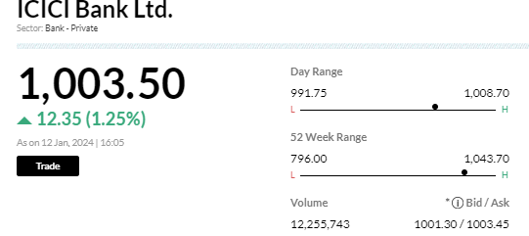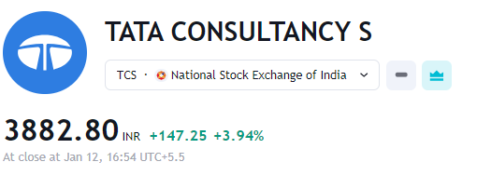

1. Line Graph, instead of candlesticks, would be easier to comprehend.

Line graph for prices + bar graphs for volumes

Time stamp 6 m, 1 yr, 3yr, 5 yr etc.

***CHART 1***

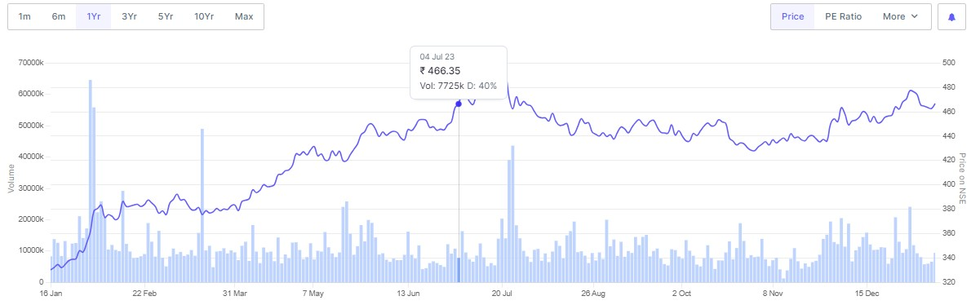

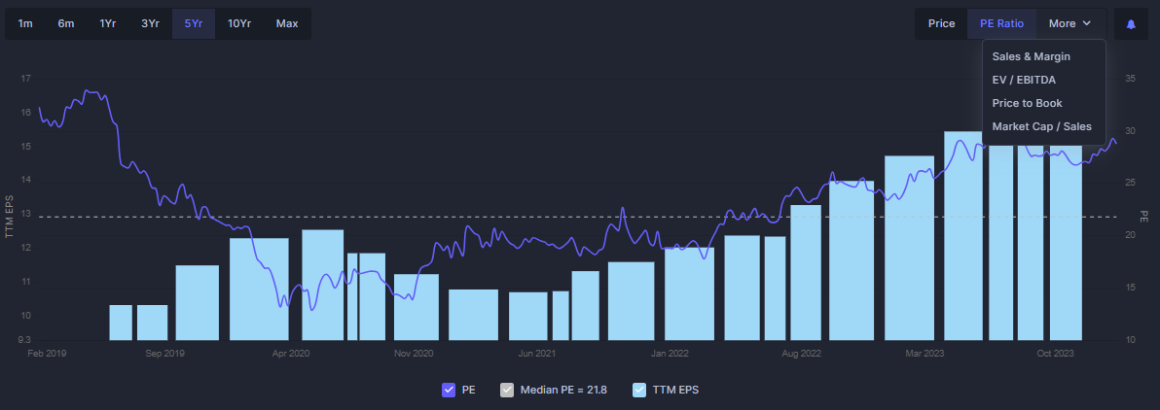

Can we also incorporate the ev/ebitda, ev/sales, p/e ratio in a drop-down kind of option within the price and volume chart.

**Chart 2 or Trend using sparkline**

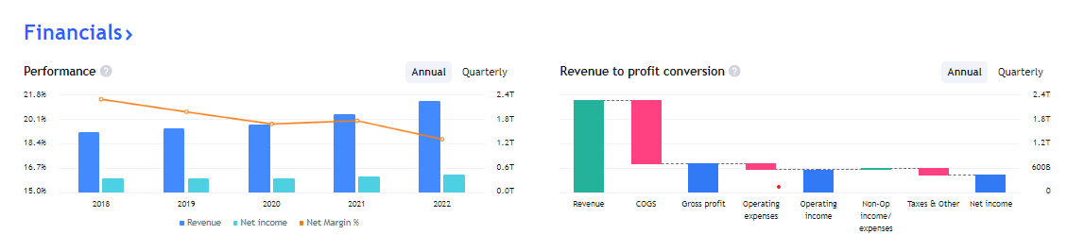

**OR**

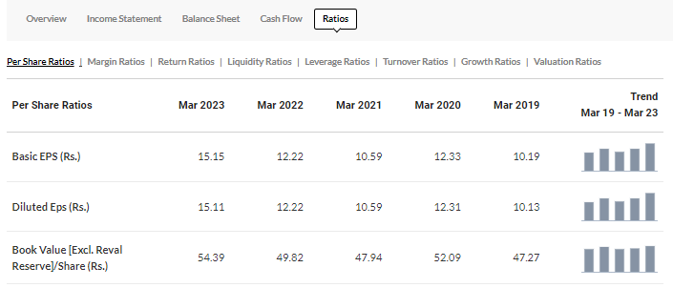

2)Key Metrics to be shown at Top

**Overall Ratios**: Market Cap, Beta, 52 weeks high low, Net Income, ROE, EPS, PE Ratio.

OR

**Key Ratio Wise**: Asset Turnover Ratio (**Turnover/efficiency**), Net Profit Margin (**Profitability)**, ROE/EPS (**Profitability**), Debt Equity (**Solvency Ratio**), EV/EBITDA (**Valuation Ratio),** P/E ratio (**Valuation Ratio)**

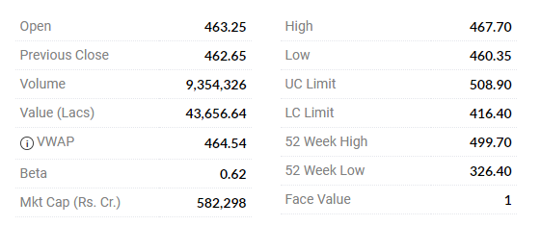

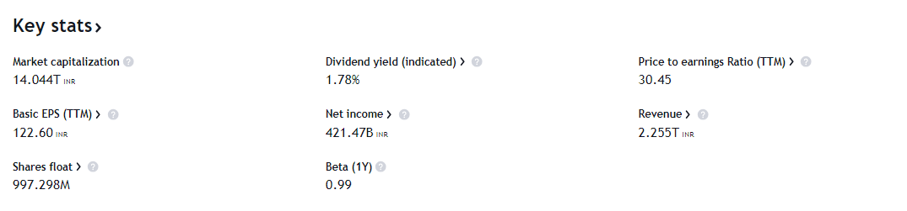

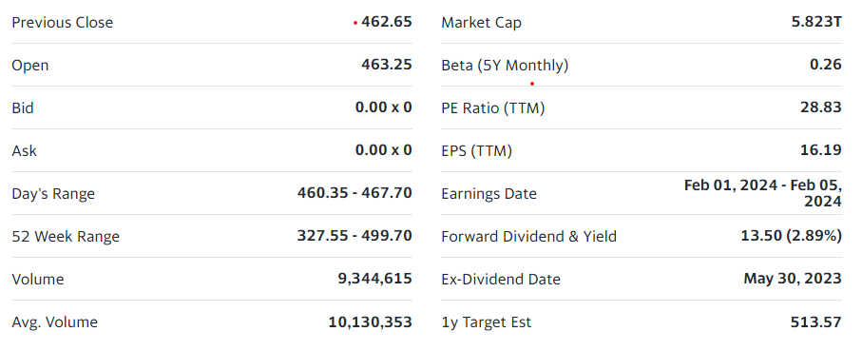

**3)**

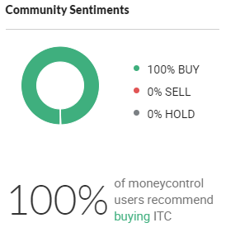

**Something similar of this sort can be put, showing undervalued / overvalued, correctly priced based on our valuation ratio analysis.**

1. **We have calculated ebit, ebitda, net profit etc growth rate over years. We can show 1,3,5, 10 years growth rate as well in a tabular format.**

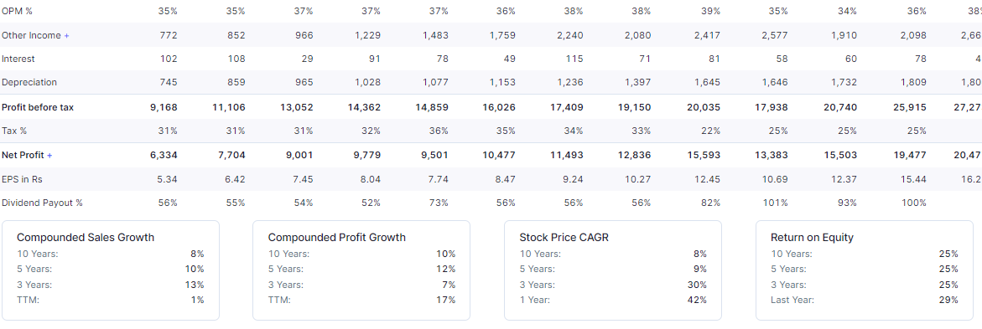

1. Shareholder Pattern: Year wise data available on Screener, excel can be downloaded.

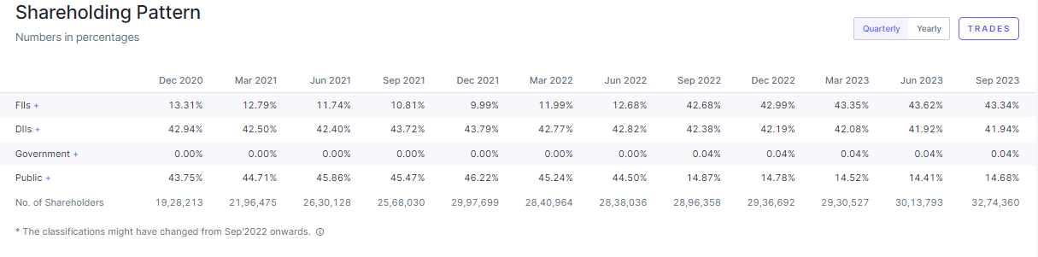

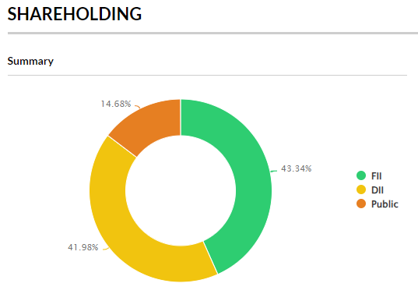

**Additional Info:**

**Link to the Annual Report, credit rating, company’s website, investor relations tab etc.**

